June 29, 2020

Subject: Bid No. 7124.6 Pest Control Materials

Contract Amendment Number 1

In accordance with the terms of the above-mentioned contract, this is authorization to extend this contract, through April 29, 2021. All other terms and conditions remain the same.

Supplier(s): See attached Summary of Contracts for suppliers and pricing information

COMMENTS: This is the one of four option to extend the contract.

REFER QUESTIONS TO: Laly Bowers, CPPB, Buyer II at Laly_A_Bowers@mcpsmd.org

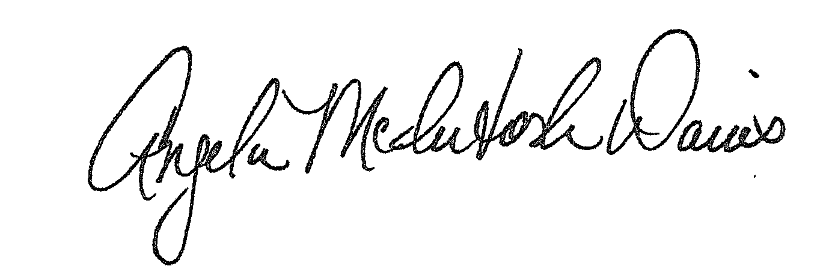

Approved:
Angela McIntosh-Davis, CPPB, Team Leader, Procurement Unit

AMD:lab

Distribution: Supplier(s); Bid File

